**WEEK 1 TASK**

**Installing the Power BI**

We can install Power BI on Microsoft website or and also we use this link

[**https://www.microsoft.com/enus/download/details.aspx?id=58494**](https://www.microsoft.com/enus/download/details.aspx?id=58494)

you will get the webpage like this

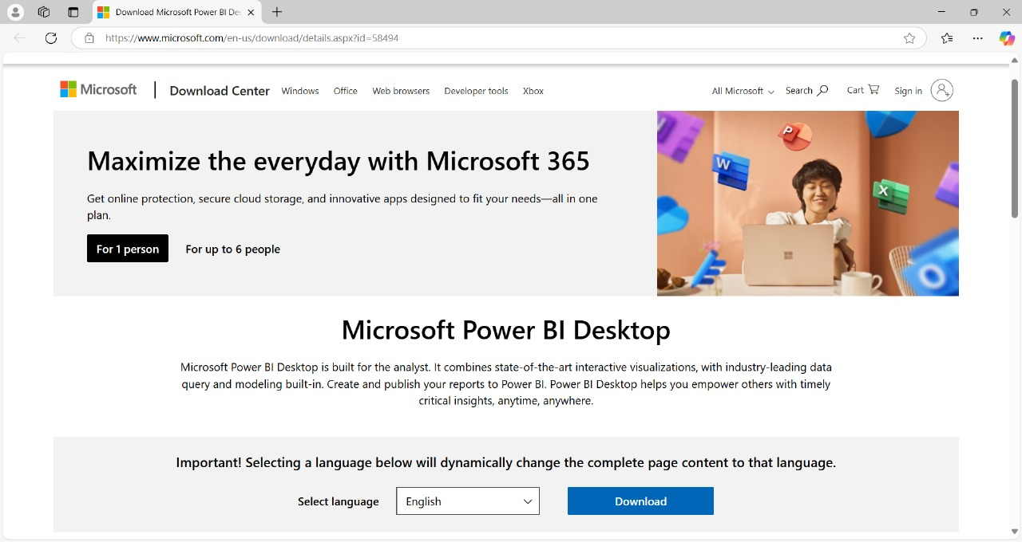

Now click download option then install the Power BI on your personal laptop.

To Install given the required information like path setting and finish the installation.

After Installation you will able to open the Power BI dashboard it looks like

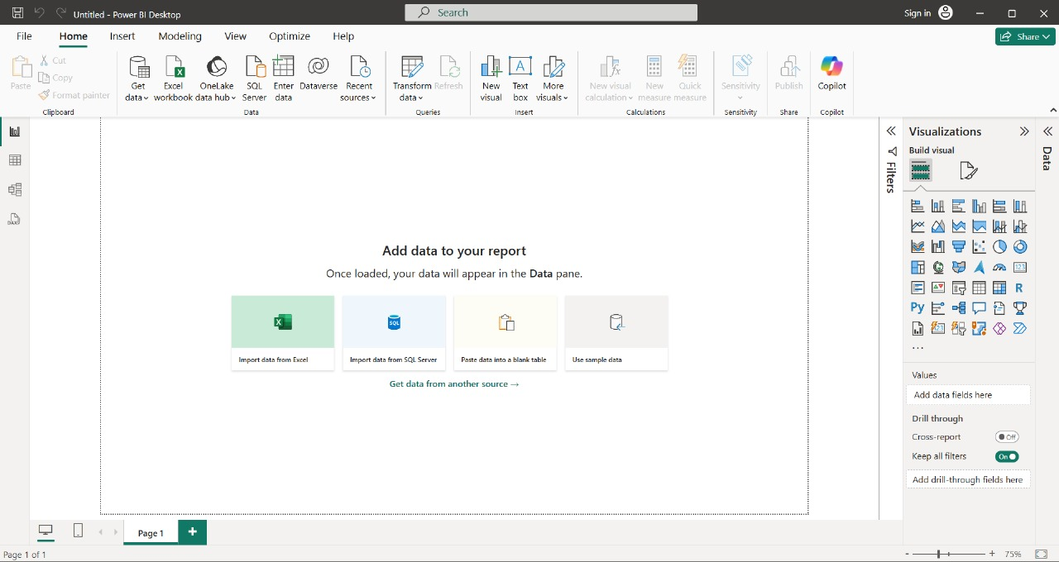

To Visualize the data we need Data Source. To Connect the data with the Power BI click the option “ Get Data ” to connect the source data to the power BI.

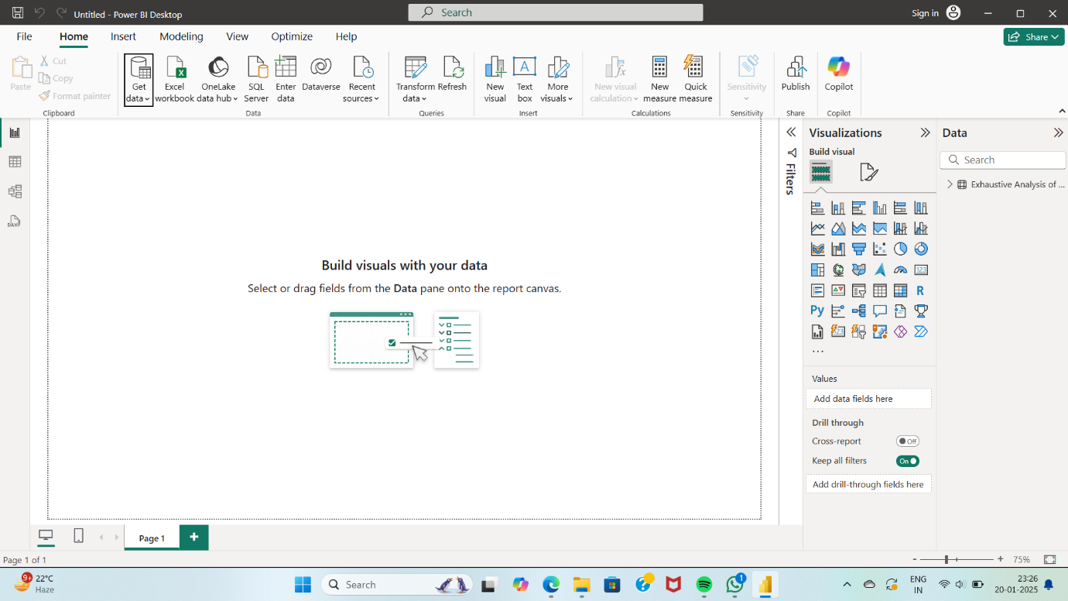

After selecting the required data, It will open one window like

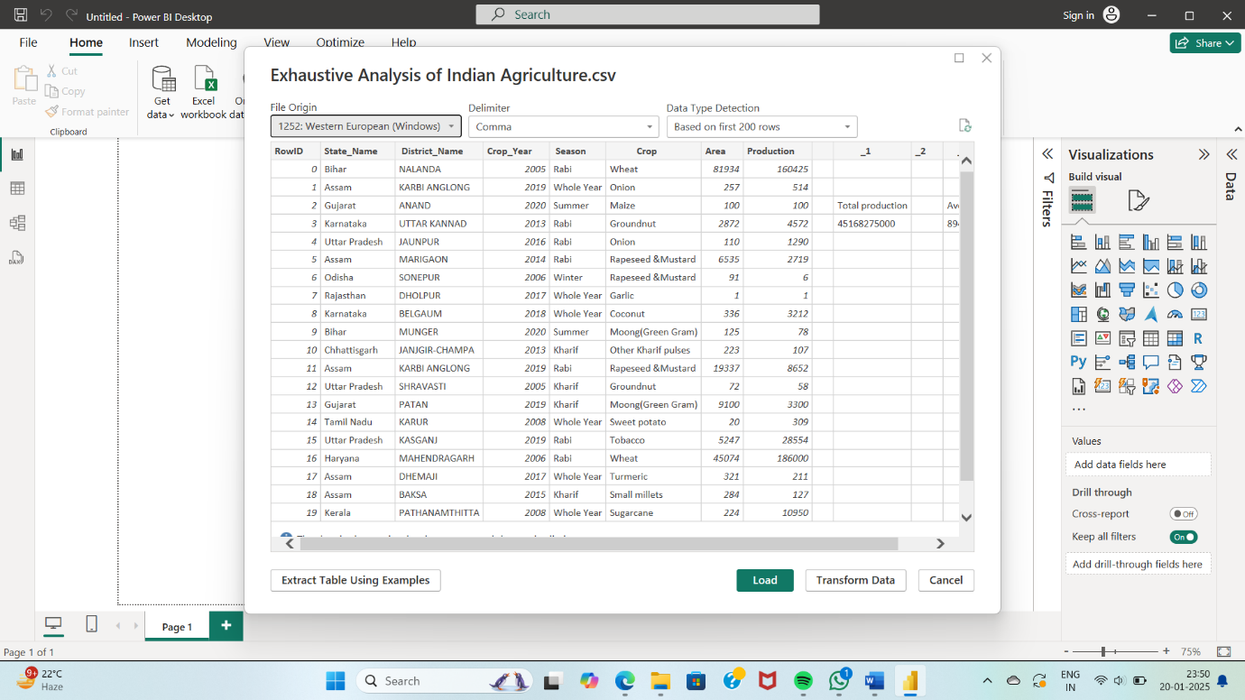

In this window we have Load option, Transform Option and cancel option.

You have to click the **Load** option when your data is cleaned.

If you want to process the data click the **Transform Data** option.

After loading the data into the Power BI, It provides the views of the data on the left of the canvas.

We have the mainly important three views.

They are:

**1. Report view**

Report view mainly used for the visualization of the data in the form of charts, graphs etc.

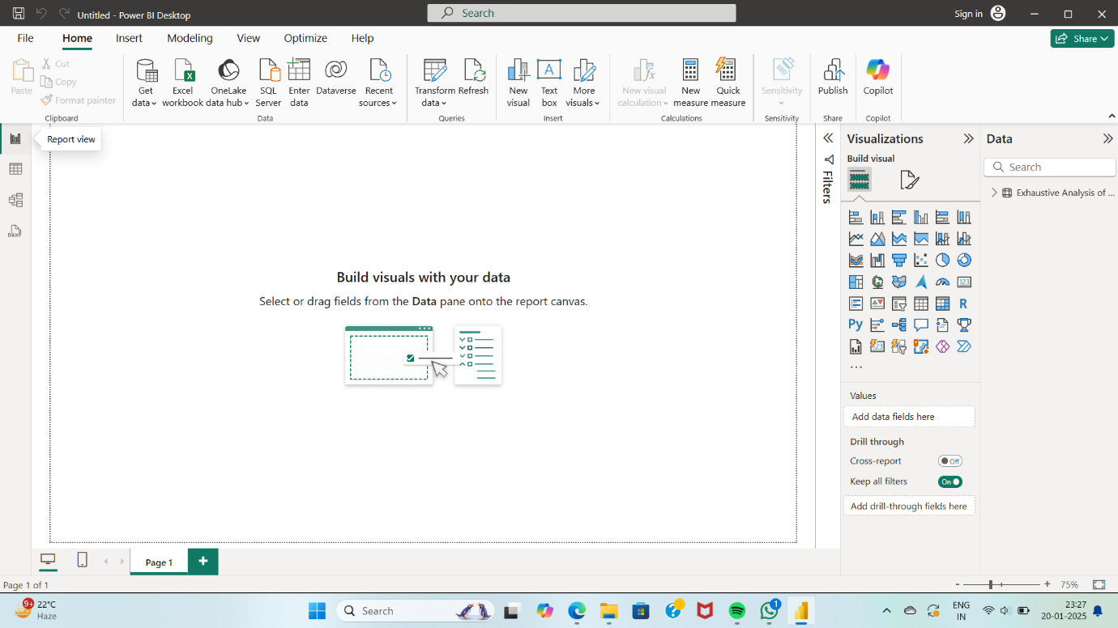

**2. Table View**

In table view ,we will see the data which we load into the Power BI.

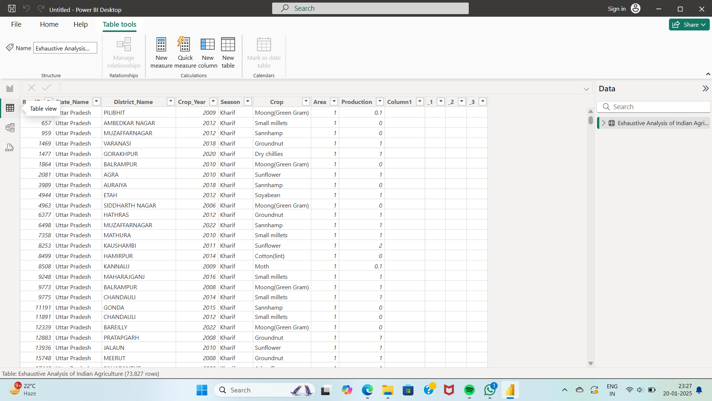

**3. Model View**

In Model view, we can create the relationship among the data.

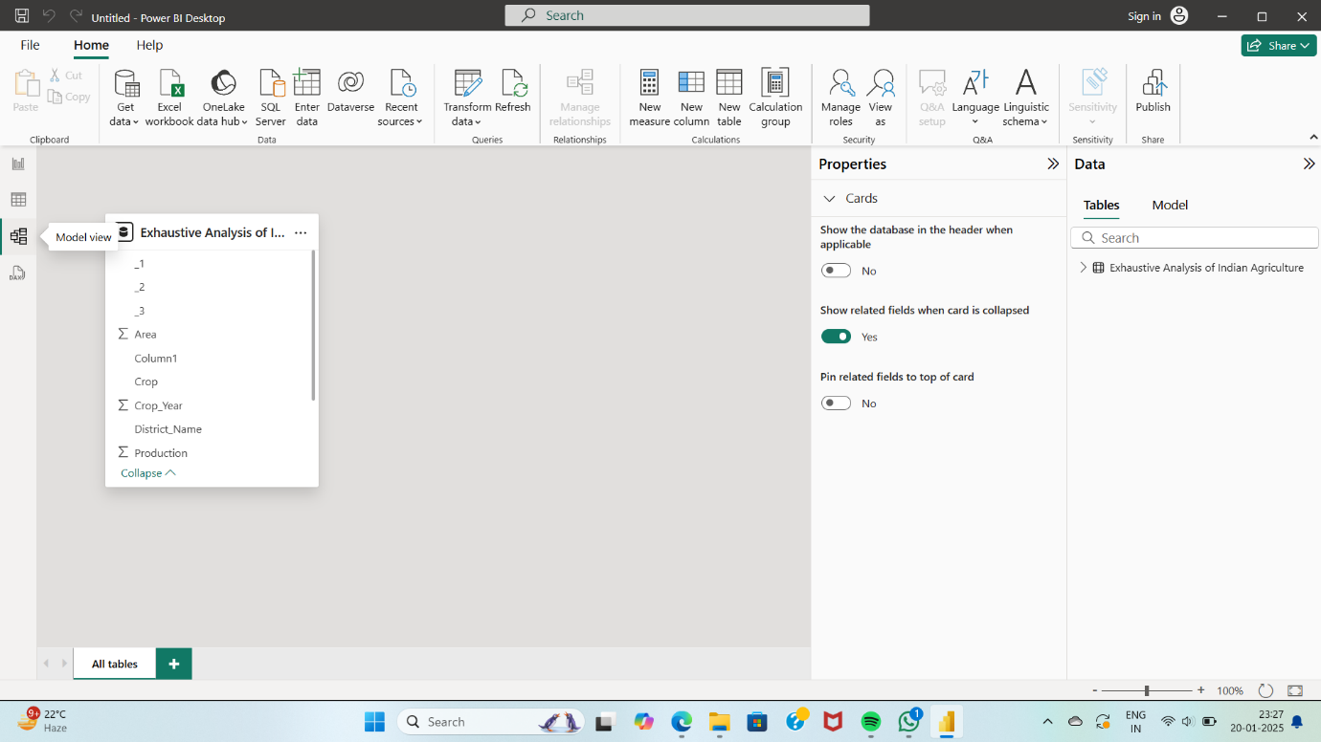

If you want to transform the data like If you want to check the empty values among the data for a particular column, you need to click the icon of Transform the data.

It will open one window, which contains source data with respective columns.

If you want to check the empty values in the columns, Right click on the particular column and select the empty and click ok.

If that column contains it will represent the empty set.

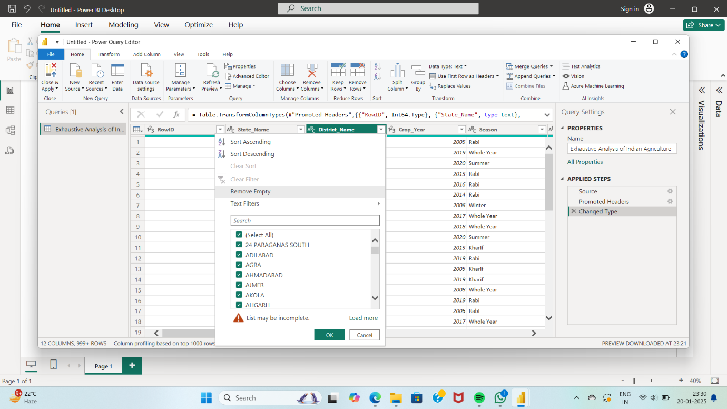

So, In this process we can process the data like we can clean the data by clearing the empty sets and redundant values in the data to get the clear analysis.